**DOC Bill Application and Reimbursement Management System**



An Initial Report submitted by:

* Rishabh Singh (Team Leader)
* Alok Ranjan
* Animesh Ranjan
* Sunny Kumar

Submission Deadline: 16th September 2019

Course Instructor : Biswajit R Bhowmik

Department : Computer Science Engineering

College : Indian Institute of Information Technology

Bhagalpur

# Table of Contents

1. Introduction
2. Design Architecture
3. Material Requirements
4. **Introduction**

This project is aimed at developing a system by which the employees such as Departments HOD, Hostel wardens in the institute can submit the DOC bills to the Administration. The bills could of various types and also of various amounts. The applicant after submitting the bill will automatically receive confirmation mail on successful submission of bill. The bill will pass through a workflow process. An email will be sent to the concerned people to let them know about the status of the bill.

The project has been planned to be having the view of distributed architecture, with centralized storage of the database. The application for the storage of the data has been planned. Using the constructs of MS-SQL Server and all the user interfaces have been designed using the ASP.Net technologies. The database connectivity is planned using the “SQL Connection” methodology. The standards of security and data protective mechanism have been given a big choice for proper usage. The application takes care of different modules and their associated reports, which are produced as per the applicable strategies and standards that are put forwarded by the administrative staff.

1. **Design Architecture**

The outline and overview structure of DOC bill Application and Management System software.

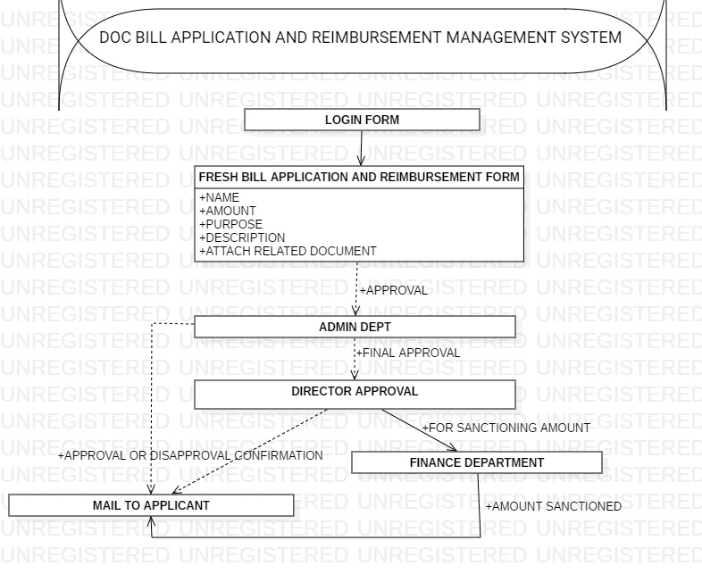

**WORK FLOW:**

* Access control to the application is managed using User Authorisation using username and Authentication using password.
* After Logging in User fills the application form and attach the related document and submit.
* After submission, Request is send to Administration department, this should be done automatically.
* Request once approved by Administration department is sent for Director’s approval, if request is rejected in any case, email is sent to applicant for necessary action.
* After Director’s approval, Finance manager after receiving the request has to credit the user account and has to send the request to the applicant with proper comments as appropriate.

Screenshots of Login page which contains textbox for username and password, drop down menu for selecting type of applicant and also a Login button.

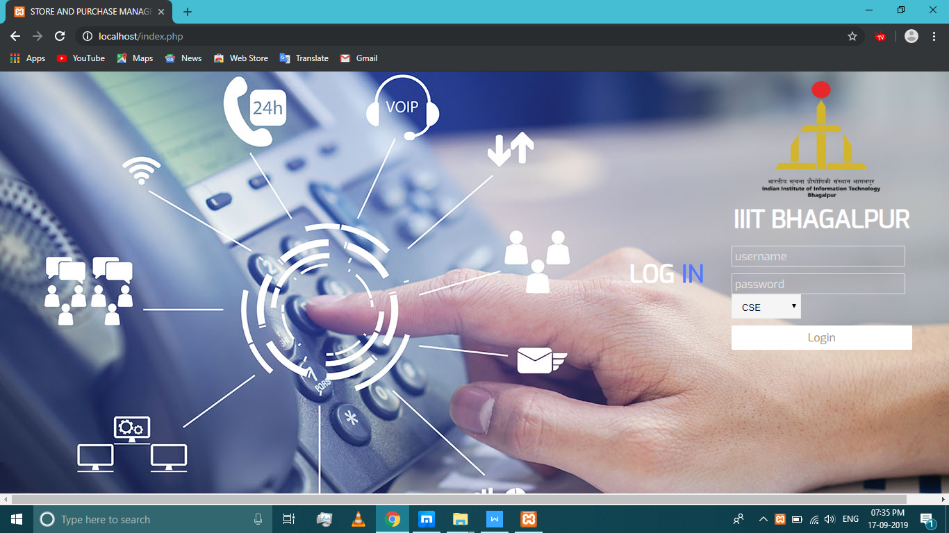

HTML code screenshot of the Login page:

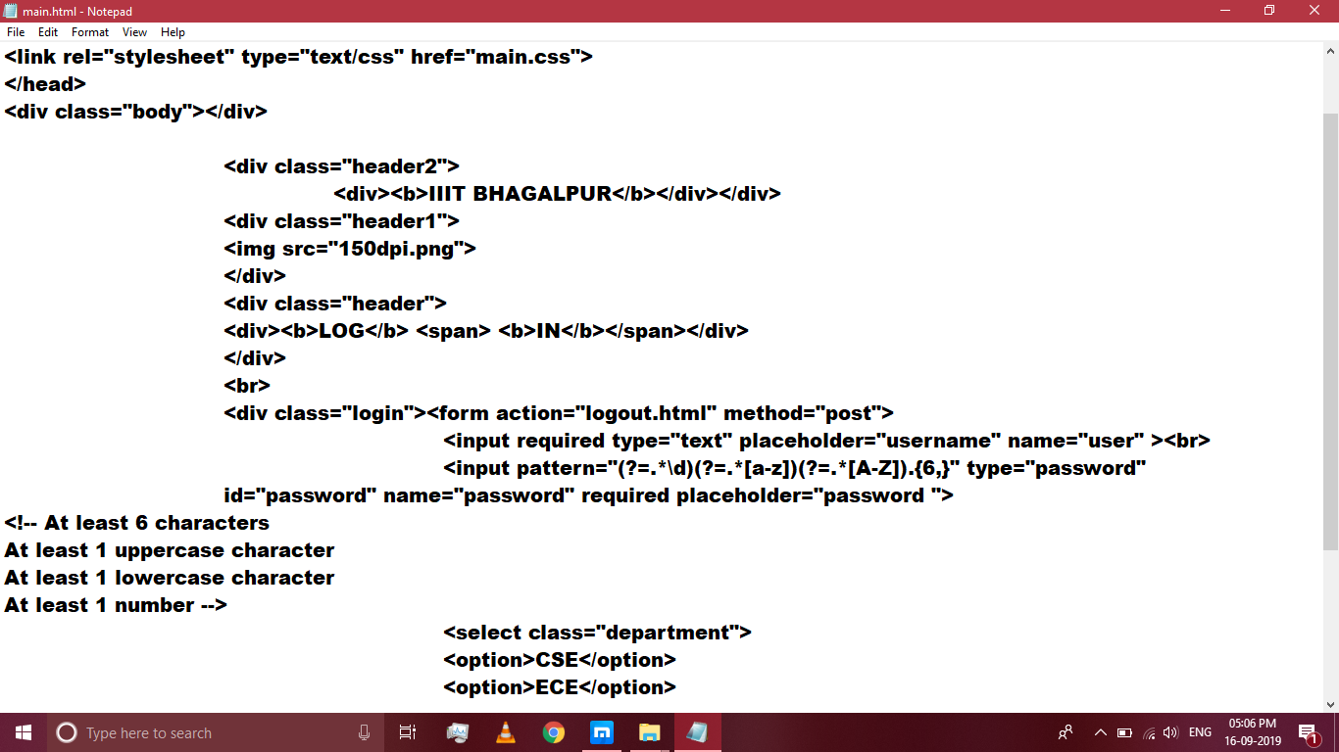

**2.1 HTML Code:**

**<?php**

**include('connect.php'); // Includes Login Script**

**if(isset($_SESSION['login_user'])){**

**header("location: main.html"); // Redirecting To Profile Page**

**}**

**?>**

**<html>**

**<head>**

**<title>STORE AND PURCHASE MANAGEMENT</title>**

**<link rel="stylesheet" type="text/css" href="main.css">**

**</head>**

**<div class="body"></div>**

**<div class="header2">**

**<div><b>IIIT BHAGALPUR</b></div></div>**

**<div class="header1">**

**<img src="150dpi.png">**

**</div>**

**<div class="header">**

**<div><b>LOG</b> <span> <b>IN</b></span></div>**

**</div>**

**<br>**

**<div class="login"><form action="connect.php" method="post">**

**<input required type="text" placeholder="username" name="user" ><br>**

**<input pattern="(?=.*\d)(?=.*[a-z])(?=.*[A-Z]).{6,}" type="password" id="password" name="password" required placeholder="password ">**

**<!-- At least 6 characters**

**At least 1 uppercase character**

**At least 1 lowercase character**

**At least 1 number -->**

**<select class="department">**

**<option>CSE</option>**

**<option>ECE</option>**

**<option>MECH</option>**

**<option>H-WARDEN</option>**

**</select>**

**<input type="submit" value="Login"></form>**

**</div>**

**</html>**

1. **Materials Required**
2. **Technology used**: HTML for frontend and MYSQL and php for backend database connectivity.
3. **Efforts**: We require 4 individuals manpower and 30 Engineer-hours to complete this project.
4. **Hardware Requirements:**

* PIV 2.8 GHz Processor and Above
* RAM 512MB and Above
* HDD 20 GB Hard Disk Space and Above

1. **Software Requirements:**

* WINDOWS OS (10/8/8.1/7.1/XP / 2000 / 200 Server / 2003 Server)
* SQL Server 2000 Enterprise Edition
* Star UML 3.1.0